GitHub Notes - <https://guides.github.com/>

# **Creating a new project / Repository**

Open Git Bash.

$ git init

$ git add .

$ git commit -m "First commit"

$ git remote add origin https://github.com/DM-08/Whist.git

$ git push origin master

#Get updates from server to local repository

$ Git pull origin master

**Delete repository:**

Go into repository. Select settings. Go to danger zone at the bottom and select delete.

**#GIT PUSH FROM LOCAL TO REPOSITORY**

* Git add
* Git commit -m “” / -a (removes the need to add first)
* Git push origin master

<https://stackoverflow.com/questions/6143285/git-add-vs-push-vs-commit>

#GIT VERSION

$git --version

#GIT CLONE

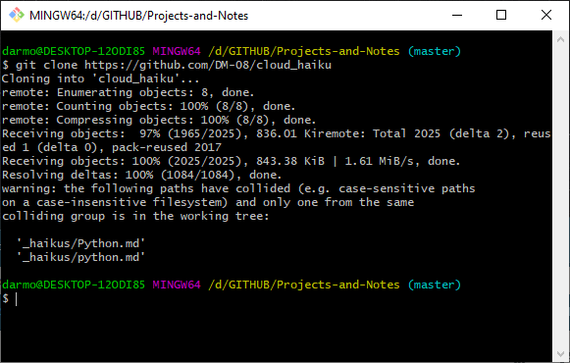

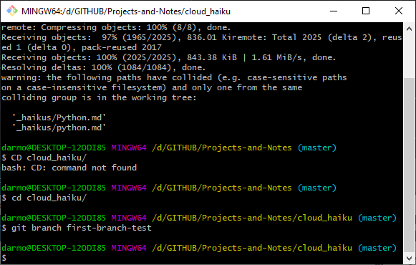

git checkout master

The checkout command will allow you to switch between multiple branches, so you can potentially work on multiple features at once.